**19**

**The First Law of Thermodynamics**

|  |
| --- |
| **CHAPTER OUTLINE** |

19.1 Heat and Internal Energy

19.2 Specific Heat and Calorimetry

19.3 Latent Heat

19.4 Work and Heat in Thermodynamic Processes

19.5 The First Law of Thermodynamics

19.6 Energy Transfer Mechanisms in Thermal Processes

* An asterisk indicates a question or problem new to this edition.

|  |
| --- |
| **SOLUTIONS TO THINK-PAIR-SHARE AND ACTIVITIES** |

**\*TP19.1 Conceptualize** Energy will leave the warm interior of the house by thermal conduction through the walls, windows, and roof to the colder air outside. To maintain the interior temperature, natural gas must be burned to warm the air inside the house.

**Categorize** This is a thermal conductivity problem.

**Analyze** We will use Equation 19.17 and recognize the power as the rate at which energy transfers out of the house by heat:

 (1)

To evaluate the amount of energy that leaves the house by heat in a given time interval, we must evaluate the areas of the walls and roof. Because an average thermal conductivity is provided for all surfaces, we can substitute the total area of the surfaces in Equation (1). Identify the length of the front of the house as *L*, the length of the side as *w*, the height of the front and back walls as *h*, and the pitch of the roof as **. Then, we have the following areas:



Substitute numerical values:



Adding these together, we find the total area to be *A*total = 304 m2. Substituting numerical values into Equation (1), we have



From this amount of energy, determine the volume of natural gas required to be burned in one day:



(b) Let’s now investigate the possibilities listed in part (b) of the problem statement. (i) The ground generally tends to be cooler than the interior temperature of a house, so there will be a transfer of energy out of the house through the floor. This will *increase* the gas requirements to replace this energy. (ii) Radiation incident on the roof and walls will warm those outer surfaces to a temperature higher than the exterior air temperature. As a result, the conduction of energy through those surfaces will not be as high as we calculated. This will *decrease* the gas requirements. Radiation through the windows, assuming the curtains are open, will deliver energy directly to the interior. Therefore, all radiation will *decrease* the gas requirements. (iii) Operation of any electrical appliances, computers, and entertainment systems represents an input of energy to the house by electrical transmission. This energy eventually becomes internal energy in the house. This will *decrease* the gas requirements. (iv) Leakage of air around windows and doors will allow warm air to escape from the house and cold air to enter the house. This will *increase* the gas requirements.

**Finalize** As you can see, estimates of energy requirements for homes and buildings can be very complicated.

*Answers:* (a) 38.6 m3 (b) (i) increase (ii) decrease (iii) decrease (iv) increase

**\*TP19.2 Conceptualize** In the initial part of the problem, we are to assume a spherical object with no atmosphere. The only thermodynamic processes we can envision for such an object is (1) energy coming in by mostly infrared, visible, and ultraviolet light from the Sun and absorbed on the surface, and (2) energy going out by mostly infrared radiation from the surface according to Equation 19.21. The balance of these energy transfers will determine the surface temperature.

**Categorize** We model the object as a *nonisolated system* in *steady state:* energy is entering and leaving the system, but the rates of these exchanges are equal in magnitude, so the internal energy of the system remains fixed.

**Analyze** (a) The appropriate reduction of Equation 8.2 for this situation is

 (1)

We can write an energy balance equation in terms of power by differentiating this equation with respect to time:



Stefan’s law, Equation 19.21, can be used for the output power:

 (3)

where the minus sign indicates that energy is leaving the system of the object and we have set the emissivity *e* = 1. For the input power, use the definition of intensity, Equation 16.38:

 (4)

where *I*in is the intensity of solar radiation impinging on a particular object and *A*circle is the circular cross section of the object perpendicular to the Sun. We modify Equation (4) in two ways. First, 30.0% of the incoming radiation is reflected away and does not contribute to warming the planet. Therefore, we include only the remaining 70.0%:

 (5)

Secondly, the intensity of radiation from the Sun varies as the inverse square of the distance of the object from the Sun. We are given the intensity at the position of the Earth, so Equation (5) can be written

 (6)

where *d* is the distance of a particular object from the Sun and *IS* is the solar intensity at the Earth. Substitute Equations (3) and (6) into Equation (2) and evaluate the circular cross section and surface area of the object in term of its radius *r*:

 (7)

Solve Equation (7) for the equilibrium temperature *T*:

 (8)

Substitute numerical values:

 (9)

(b) From the data in Table 13.2, we find the following, where the theoretical surface temperature is found from Equation (9):

|  |  |  |
| --- | --- | --- |
| **Object** | **Distance from Sun (1010 m)** | **Surface Temperature (K)**  **(from Equation 9)** |
| Mercury | 5.79 | 410 |
| Venus | 10.8 | 300 |
| Earth | 14.96 | 255 |
| Mars | 22.8 | 207 |
| Ceres | 41.4 | 153 |
| Jupiter | 77.8 | 112 |
| Saturn | 143 | 82.5 |
| Uranus | 287 | 58.2 |
| Neptune | 450 | 46.5 |
| Pluto | 591 | 40.6 |

(c) The bar graph for the data in part (b) looks like the following:

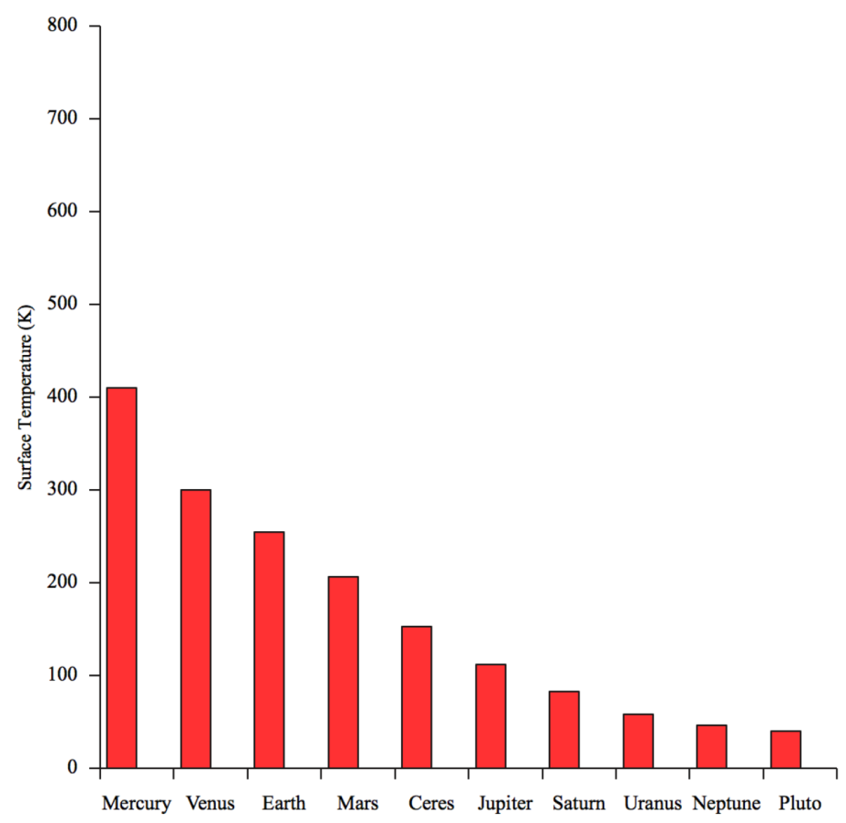

(d) Let’s add to the table the surface temperatures from the Lunar and Planetary Institute:

|  |  |  |  |  |
| --- | --- | --- | --- | --- |
| **Object** | **Distance from Sun (1010 m)** | **Surface Temperature (K)**  **(from Equation 9)** | **Surface Temperature (K)**  **(from the Lunar and Planetary Institute)** | **% difference** |
| Mercury | 5.79 | 410 | 440 | 7.32 |
| Venus | 10.8 | 300 | 741 | 147 |
| Earth | 14.96 | 255 | 288 | 12.9 |
| Mars | 22.8 | 207 | 244 | 17.9 |
| Ceres | 41.4 | 153 | 173 | 13.1 |
| Jupiter | 77.8 | 112 | 165 | 47.3 |
| Saturn | 143 | 82.5 | 134 | 62.4 |
| Uranus | 287 | 58.2 | 77 | 32.3 |
| Neptune | 450 | 46.5 | 70 | 50.5 |
| Pluto | 591 | 40.6 | 40 | –1.48 |

Adding the new data from the Lunar and Planetary Institute gives the bars in green on our graph:

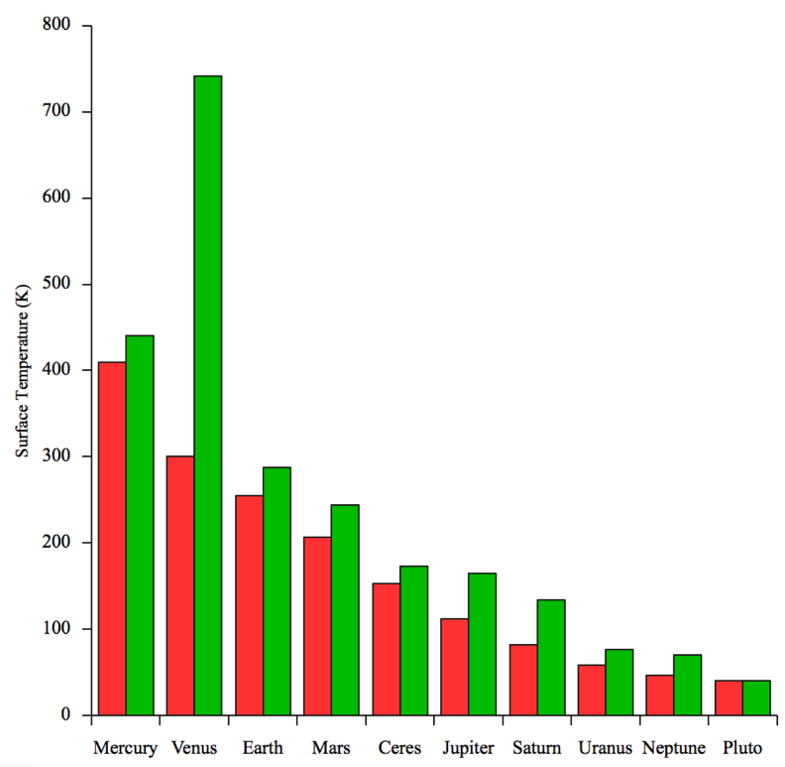

(e) This fact is essential to the evolution of life on Earth. The presence of liquid water allows the development of organisms with which we are familiar. The greenhouse effect has allowed life to evolve on Earth, but is presently causing problems with climate change.

(f) The theoretical and measured temperatures for these objects are close together. Pluto is very close, with only about a 1% difference. Because the atmospheres on these planets are thin, they serve as good examples of the model of the atmosphere-free object that we set up in the problem. Mercury’s albedo is actually only 0.068, so our general estimate of 0.300 is not appropriate for that planet. Also, Mercury does not satisfy the assumption that the temperature of the surface is uniform, since it is tidally locked to the Sun. The temperature of the “day” side is 427 – 440°C and the “night” side temperature is –173°C, giving the average temperature reported in the table.

(g) The theoretical and measured temperatures for these planets are *not* close together. The differences range from 32% to 62%. These planets have thick, complex atmospheres, with a strong greenhouse effect.

(h) The atmosphere of Venus is 96% carbon dioxide. While carbon dioxide is the primary culprit responsible for climate change on Earth, the Earth’s atmosphere has less than 0.1% carbon dioxide. Carbon dioxide molecules are more massive than oxygen and nitrogen, so the Venusian atmosphere is very dense, with a much higher pressure at the surface than on Earth. Because of this increased density and the preponderance of the greenhouse gas carbon dioxide, a runaway greenhouse effect has caused the surface temperature to rise to a very high value.

(i) The measured temperature of Mars is about 18% higher than the theoretical temperature. This would suggest an active greenhouse effect going on the atmosphere. In fact, this discrepancy is higher than that for Earth, for which the measured temperature is about 13% higher than the theoretical temperature. This might be surprising, considering that the pressure of the atmosphere on Mars is only 0.6% of that on Earth. But if we look at atmospheric composition, we see that the Martian atmosphere is 96% carbon dioxide, like Venus. So Mars has the absorption of infrared radiation from the surface contributing to a greenhouse effect, but the much lower density of the atmosphere compared to Venus results in a much more modest temperature increase than on Venus.

**Finalize** It is remarkable how much physics and planetary science we have been able to discuss from this relatively simple exercise.

*Answers:* Answers will vary.

|  |
| --- |
| **SOLUTIONS TO END-OF-CHAPTER PROBLEMS** |

Section 19.1 Heat and Internal Energy

**P19.1** (a) The energy equivalent of 540 Calories is found from



(b) The work done lifting her weight *mg* up one stair of height *h* is   
*W*1 = *mgh*. Thus, the total work done in climbing *N* stairs is *W* = *Nmgh*, and we have *Q* = *Nmgh,* or



(c) If only 25% of the energy from the donut goes into mechanical energy, we have



Section 19.2 Specific Heat and Calorimetry

**P19.2** As mass *m* of water drops from top to bottom of the falls, the gravitational potential energy given up (and hence, the kinetic energy gained) is *Q* = *mgh*. If all of this goes into raising the temperature,   
** and the rise in temperature will be



and the final temperature is



**P19.3** The system is thermally isolated, so



**P19.4** We find its specific heat from the definition, which is contained in the equation ** for energy input by heat to produce a temperature change. Solving, we have





**\*P19.5 Conceptualize** When the eggs are cooking, they are in boiling water, so their temperature is 100°C. They are then transferred to 23.0°C water, and the combination of eggs and water reaches an equilibrium temperature of 40.0°C.

**Categorize** This is a calorimetry problem: you are mixing hot eggs and cool water.

**Analyze** We use Equation 19.5:

 (1)

Substitute for each side of the equation, water on the left, eggs on the right:

 (2)

Solve for the required mass of water:

 (3)

Substitute numerical values:



**Finalize** The mass of water that we found corresponds to a volume of about a liter of water, or, in common U.S. kitchen measurements, close to a quart.

*Answer:* 0.918 kg

**P19.6** We use  to find the equilibrium temperature:







Solving for the final temperature gives



**P19.7** (a) To find the specific heat of the unknown sample, we start with *Q*cold = –*Q*hot and substitute:



where *w* is for water, *c* the calorimeter, Cu the copper sample, and “unk” the unknown.



(b) 

(c) 

**P19.8** (a) The work that the bit does in deforming the block, breaking chips off, and giving them kinetic energy is not a final destination for energy. All of this work turns entirely into internal energy as soon as the chips stop their macroscopic motion. The amount of energy input to the steel is the work done by the bit:



To evaluate the temperature change produced by this energy we imagine injecting the same quantity of energy as heat from a stove. The bit, chips, and block all undergo the same temperature change. Any difference in temperature between one bit of steel and another would erase itself by causing an energy transfer by heat from the temporarily hotter to the colder region.



(b) See part (a). The same amount of work is done. 

(c) 

**P19.9** (a) Expressing the percentage change as *f* = 0.60, we have





which gives 

(b) 

**Section 19.3 Latent Heat**

**P19.10** The energy input needed is the sum of the following terms:



Thus, we have



P19.11 We assume that all work done against friction is used to melt the snow. Equation 8.2 for conservation of energy then gives



or 

where 

Substituting and solving for the distance gives



**P19.12** The bullet will not melt all the ice, so its final temperature is 0°C.

Then, conservation of energy gives



where *mw* is the mass of melted ice. Solving for *mw* gives,



**P19.13** (a) Since the heat required to melt 250 g of ice at 0°C *exceeds* the heat required to cool 600 g of water from 18°C to 0°C, the final temperature of the system (water + ice) must be 

(b) Let *m* represent the mass of ice that melts before the system reaches equilibrium at 0°C.



**P19.14** (a) Let *n* represent the number of stops. Follow the energy:



Thus  stops can happen before melting begins.

(b) 

**Section 19.4 Work in Thermodynamic Processess**

**P19.15** During the warming process 

(a) 



(b) *PV* = *nRT* gives





**P19.16** (a) 



(b) 

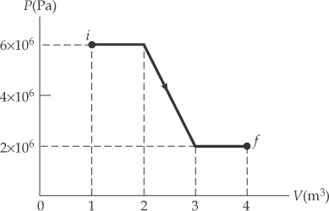

ANS. FIG. P19.16

Section 19.5 The First Law of Thermodynamics

**P19.17** From the first law of thermodynamics,  so



The negative sign indicates that positive energy is transferred *from* the system by heat.

**P19.18** From the first law of thermodynamics,



The change in internal energy is a positive number, which would be consistent with an *increase* in temperature of the gas, but the problem statement indicates a *decrease* in temperature.

**P19.19** (a) Rearranging *PV* = *nRT* we get 

The initial volume is



For isothermal compression, *PV* is constant, so *PiVi* = *PfVf*  and the final volume is



(b) 

(c) The ideal gas keeps constant temperature so  and the heat is 

**P19.20** (a) We choose as a system the H2O molecules that all participate in the phase change. For a constant-pressure process,

**

where *Vs* is the volume of the steam and *Vw* is the volume of the liquid water. We can find them respectively from



Calculating each work term,



Thus the work done is

*W* = −3 101 J + 1.82 J = 

(b) The energy input by heat is

**

so the change in internal energy is



**P19.21** (a) 

(b) 

(c) 

**P19.22** From conservation of energy,

(a) From the first law of thermodynamics, we have



Then,



(b)   and 

Then, 

(+ means that work is done on the system)

(c) *WCDA* = *WCD* so that



(– means that energy must be removed from the system by heat)

(d) 

and 

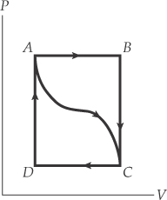

ANS. FIG. P19.22

Section 19.6 Energy Transfer Mechanisms in Thermal Processes

**P19.23** The net rate of energy transfer from his skin is



Note that the temperatures must be in kelvins. The energy loss in ten minutes is



In the infrared, the person shines brighter than a hundred-watt light bulb.

**P19.24** The thermal conductivity of concrete is *k* = 1.3 J/s · m · ºC, so the energy transfer rate through the slab is



**P19.25** (a) Because the bulb is evacuated, the filament loses energy by radiation but not by convection; we ignore energy loss by conduction. We convert the temperatures given in Celsius to Kelvin, with *Th* = 2 100°C = 2 373 K and *Tc* = 2 000°C = 2 273 K. Then, from Stefan’s law, the power ratio is



(b) The radiating area is the lateral surface area of the cylindrical filament,  Now we want



so 

**P19.26** We use Equation 20.16 for the rate of energy transfer by conduction:



Since this is much less than 240 kcal/h, blood flow is essential to cool the body.

**P19.27** (a) The *R*-value of the window is the sum of the *R*-values for the two 0.125-in window panes, which Table 19.4 lists as 0.890, plus the layer of air in between. Since the Table 19.4 lists the *R*-value for an air space of 3.50 in, the total *R*-value becomes



(b) Since *A* and (*T*2 – *T*1) are constants, heat flow is reduced by a factor of 

**P19.28** (a) The heat leaving the box during the day is given by





The heat lost at night is



The total heat is 1.19 × 105 J + 7.90 × 104 J = 1.98 × 105 J. It must be supplied by the solidifying wax: *Q* = *mL*



(b) 

**Additional Problems**

P19.29 The constant pressure is



and the work done on the gas is 

(a) Here,  and



(b) In this case,  so



*P19.30 **Conceptualize** Imagine Icarus using his wings to move upward in the air from the island of Crete. In reality, the temperature of the air decreases as you move upward in the atmosphere, so the chance of the wings melting decreases!

**Categorize** The analysis model that leads to the equation in the problem is the nonisolated system in steady-state (energy), as the energy input from the Sun is balanced with energy output by radiation from the object. However, since we are given the result of that model in the problem, this becomes a substitution problem.

Solve the equation given for the distance *r*:



Substitute the melting temperature of the wax:



Therefore, Icarus would have to fly almost halfway to the Sun for the temperature of the wax to rise to its melting point. There clearly is no air at that location for him to beat his wings against!

*Answer:* No, there will not be air at this location.

**\*P19.31 Conceptualize** Imagine the gas at *A* being compressed by the piston in the engine to a smaller volume at point *B*. Compressing a gas generally raises its temperature, so we expect *TB* > *TA*. Then the spark plug fires at B, almost instantaneously raising the amount of internal energy in the gas as the piston is momentarily at rest at the smallest volume of the gas. This will raise the temperature to *TC*, which is what we wish to determine.

**Categorize** We have not drawn a path from *A* to *B*, nor has this process been described in the problem, so we cannot categorize the process that occurs here. We will categorize the gas as ideal, however. From *B* to *C*, we can model this process as isovolumetric, since the energy is transformed while the piston is at rest at the smallest volume of the gas.

**Analyze** First consider process *A* → *B*. Because the gas is modeled as ideal, we can use Equation 18.9 to find the temperature of the gas at point *B*:

 (1)

Substitute numerical values from the graph:

 (2)

Because of the statement that internal energy is proportional to temperature for a gas, we can write

 (3)

Now we consider process *B* → *C*. First write Equation 19.11:

 (4)

Because this second process is isovolumetric, there is no work done on the gas. Therefore,

 (5)

Now write the internal energy of the gas at point *C* as that at *A* plus the changes of internal energy for each of the two processes *A*→*B* and *B*→*C*:

 (6)

Substitute for the changes from Equations (3) and (5):

 (7)

Substitute numerical values:



Set up the ratio of the final internal energy to the initial internal energy:



Because internal energy is proportional to temperature, this is also the ratio of the final and initial temperatures:



**Finalize** This is a very simplified model of an automobile engine. We did not show the actual path between points *A* and *B*, because we didn't need it for the calculation. In reality, as we show in Chapter 21, the path between these points in an automobile engine is modeled as adiabatic, a process introduced in Section 19.5. Notice that we did not need the initial values of the pressure or volume given in the problem.]

Answer: 888 K

**\*P19.32 Conceptualize** The rod is a thermal conductor. The upper end of the rod is at room temperature, while the lower end in the liquid helium is at 4.20 K.

**Categorize** This is a problem involving both thermal conduction and the evaporation of liquid helium.

**Analyze** We first use Equation 19.18 to determine the rate at which energy is conducting down the rod from the air into the liquid helium:

 (1)

where *Th* is the temperature of the room. This energy causes a phase change from liquid helium to helium vapor, which escapes from the top of the vessel. Differentiate Equation 19.8 to relate the rate at which energy is delivered to the rate at which liquid helium vaporizes:

 (2)

The left side of Equation (1) is the rate at which energy arrives at the cold end of the rod. The left side of Equation (2) is the rate at which energy is delivered to the liquid helium. These are the same quantities, so equate the right sides of Equations (1) and (2) and solve for the rate at which helium is vaporized:

 (3)

Substitute numerical values, assuming that the temperature of the room is *Th* = 300 K:



Convert this to a volume using Equation 1.1:



Assuming that the vessel is completely full when you measure it, the time interval to completely boil off the helium is



**Finalize** There is clearly no helium left for the next day’s experiments. In fact, it runs out in a time interval even shorter than 91.2 min. You boil off a lot of helium when you first insert the hot rod into the liquid, during the time interval it takes for the end of the rod in the liquid to cool to 4.20 K. Furthermore, we used the entire length *L* of the rod in Equation (3) to calculate the rate at which helium is vaporized. If the liquid helium is of depth *d*, then the portion of the rod at the surface of the liquid is at 4.20 K. Therefore, the distance *L* between *Th* and *Tc* in Equation (3) should be changed to *L* – *d*, leading to a higher evaporation rate.

Answer: None

**P19.33**  so that when a constant temperature difference  is maintained, the rate of adding energy to the liquid is   and the specific heat of the liquid is



**P19.34**  so that when a constant temperature difference  is maintained, the rate of adding energy to the liquid is   and the specific heat of the liquid is 

**P19.35** The disk is isolated, so angular momentum is conserved by the disk system. The initial moment of inertia of the disk is



The rotation speeds up as the disk cools off, according to





(a) The kinetic energy increases by



(b) 

(c) Solve the appropriate reduction of Equation 8.2 for the energy radiated by the disk:





**P19.36** (a) Isolated system (momentum). The collision is a perfectly inelastic collision, where momentum is conserved, but kinetic energy is not (it is transformed into internal energy).

(b) Momentum is conserved; thus:



Substituting in numerically (positive to the right):



The final velocity is 

(c) The initial kinetic energy is





The final kinetic energy is:





The amount of kinetic energy transformed into internal energy is



(d)  If this amount of heat is added to the mass of the bullets, the following amount will be needed to heat the bullets to their melting temperature:



At the beginning of the process, 1 176 joules are generated by the collision; therefore, the bullets will be heated to the melting point, with heat still available to start the melting process:



Therefore, 415 J are available to melt the bullets. The amount of heat needed to melt all of the combined mass of the two bullets is:



There are only 415 J available; so the lead does not entirely melt due to the collision.

(e) Because there is not enough energy available to melt all the mass of the bullets, the final temperature is the melting point of lead, 

(f) The total mass of the melted lead is:



leaving behind 20.0 g – 16.9 g = 3.10 g of unmelted solid lead:



P19.37 (a) 

(b) The total energy that must be removed is



or



**P19.38** (a) The chemical energy input becomes partly work output and partly internal energy. The energy flow each second is described by



(b) The rate of fat burning is ideally  The 0.044 4 kg/h of water produced by metabolism is this fraction of the water needed for cooling:  Moral: drink plenty of water while you exercise.

**P19.39** (a) The rate of energy conversion is given by



(b) Energy received by each object is (1 000 W)(10 s) = 104 J   
= 2389 cal. The specific heat of iron is 0.107 cal/g . °C, so the heat capacity of each object is 



**P19.40** (a) Work done on the gas is the negative of the area under the *PV* curve:



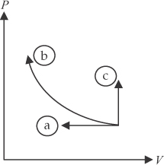 

(b) In this case the area under the curve is 

Since the process is isothermal,

ANS. FIG. P19.40



and





(c) The area under the curve is 0 and .



The student may be confused that the integral in part (c) is not explicitly covered in calculus class. Mathematicians ordinarily study integrals of functions, but the pressure is not a single-valued function of volume in a isovolumetric process. Our physics idea of an integral is more general. It still corresponds to the idea of area under the graph line.

**P19.41**  (a) The power radiated by the quiet Sun is given by Stefan’s law:



(b) The power output of the patch of sunspot is



(c) 

(d) 

**P19.42** The time interval to boil the water is related to the solar power *P* absorbed by the water and the energy transfer *T*ER required:



The energy transfer required is



The solar power is



Combining all three equations,



If we include setup time and coffee brewing time, this time interval approaches 2.5 hours. In the morning, the solar intensity is not the maximum amount, which occurs later in the day. Therefore, the reduced intensity in the morning will increase the time interval further. Furthermore, we have not included the energy transfer necessary to raise the temperature of the container in which the water resides. These considerations will push the required time interval even higher, so that most of the morning is used in making coffee and there is no time left for a morning hike.

**P19.43** Energy goes in at a constant rate *P.* For the period from 50.0 min to 60.0 min, after the ice has melted,





 **[1]**

For the period from 0 to 50.0 min, as the ice is melting,





Substitute  into equation [1] to find



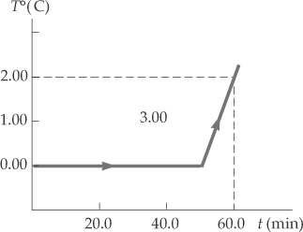

ANS. FIG. P19.43

**P19.44** (a) From conservation of energy, where the subscript *w* is for water and the subscript *c* is for the calorimeter,

 or 



(b) 



**Challenge Problems**

**P19.45** (a) See ANS. FIG. P19.45. For a cylindrical shell of radius *r*, height *L*, and thickness *dr*, the equation for thermal conduction,

 becomes 

Under equilibrium conditions,  is constant; therefore,

 and 



But *Ta* > *Tb*, so 

(b) From part (a), the rate of energy flow through the wall is



This is the rate of energy loss from the plane by heat, and consequently is the rate at which energy must be supplied in order to maintain a constant temperature.

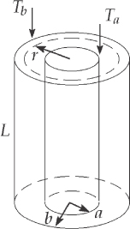

**ANS. FIG. P19.45**

**P19.46** (a) If the energy transfer *P* through one spherical surface within the shell were different from the energy transfer through another sphere, the temperature would be changing at a radius between the layers, so the steady state would not yet be established.



(b) We separate the variables *T* and *r* in the thermal conduction equation and integrate the equation between points on the interior and exterior surfaces.



where *T* is in degrees Celsius, *P* is in watts, and *r* is in meters.

(c) The integral yields





(d) With *P* now known, we separate the variables again and integrate between a point on the interior surface and any point within the shell.



(e) Integrating, we find





(f) 

**P19.47 **



|  |
| --- |
| **ANSWERS TO QUICK-QUIZZES** |

1. (i) iron, glass, water (ii) water, glass, iron

2. The figure on the next page shows a graphical representation of the internal energy of the system as a function of energy added. Notice that this graph looks quite different from Figure 19.3 in that it doesn’t have the flat portions during the phase changes. Regardless of how the temperature is varying in Figure 19.3, the internal energy of the system simply increases linearly with energy input; the line in the graph below has a slope of 1.

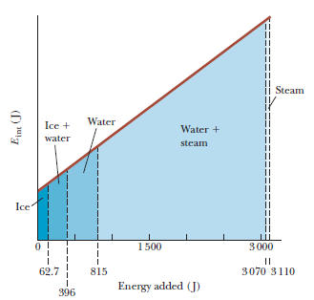

|  |  |  |  |  |
| --- | --- | --- | --- | --- |
| **3. Situation** | **System** | **Q** | **W** | **ΔEint** |
| 1. Rapidly pumping up a bicycle tire | Air in the pump | 0 | + | + |
| 1. Pan of room-temperature water sitting on a hot stove | Water in the pan | + | 0 | + |
| 1. Air quickly leaking out of a balloon | Air originally in  the balloon | 0 | _ | _ |

4. Path A is isovolumetric, path B is adiabatic, path C is isothermal, and path D is isobaric.

5. (b)

|  |
| --- |
| **ANSWERS TO EVEN-NUMBERED PROBLEMS** |

**P19.2** 16.9° C

**P19.4** 0.234 kJ/kg ⋅ °C

**P19.6** 

**P19.8** (a) 16.1°C; (b) 16.1°C; (c) It makes no difference whether the drill bit is dull or sharp, or how far into the block it cuts. The answers to (a) and (b) are the same because all of the work done by the bit on the block constitutes energy being transferred into the internal energy of the steel.

**P19.10** 1.22 × 105 J

**P19.12** 0.294 g

**P19.14** (a) 7; (b) As the car stops, it transforms part of its kinetic energy into internal energy due to air resistance. As soon as the brakes rise above the air temperature, they transfer energy by heat into the air and transfer it very fast if they attain a high temperature.

**P19.16** (a) −12.0 MJ; (b) + 12.0 MJ

**P19.18** From the first law of thermodynamics, ∆*E*int = *Q* + *W* = 10.0 J + 12.0 J = +22.0 J. The change in internal energy is a positive number, which would be consistent with an increase in temperature of the gas, but the problem statement indicates a decrease in temperature.

**P19.20** (a) −3.10 kJ; (b) 37.6 kJ

**P19.22** (a) 1 300 J; (b) 100 J; (c) −900 J; (d) −1 400 J

**P19.24** 667 W

**P19.26** 30.3 kcal/h

**P19.28** (a) 0.964 kg or more; (b) The test samples and the inner surface of the insulation can be pre-warmed to 37.0° as the box is assembled. Then, nothing changes in temperature during the test period and the masses of the test samples and insulation make no difference.

**P19.30** No, there will not be air at this location.

**P19.32** None

**P19.34** 

**P19.36** (a) Isolated system (momentum). The collision is a perfectly inelastic collision, where momentum is conserved, but kinetic energy is not. (It is transformed to internal energy); (b) 20.0 m/s to the right; (c) 1.18 × 103 J; (d) No; (e) 327.3°C; (f) 3.1 g of solid lead and 16.9 g of liquid lead

**P19.38** (a) 0.645 kg/h; (b) 0.068 9

**P19.40** (a) ; Put the cylinder into a refrigerator at absolute temperature T/2. Let the piston move freely as the gas cools; (b) +1.39*PiVi*; With the gas in a constant-temperature bath at Tf , slowly push the piston in; (c) W = 0; Lock the piston in place and hold the cylinder over at hotplate at 3Tf .

**P19.42** Most of the morning is used in making coffee, and there is no time left for a morning hike.

**P19.44** (a) 800 J/kg ∙ °C; (b) This differs from the tabulated value by 11%, so the values agree within 15%.

**P19.46** (a) The equation *dT*/*dr* = *P/4πkr*2 represents the law of thermal conduction, incorporating the definition of thermal conductivity, applied to a spherical surface within the shell. The rate of energy transfer P must be the same for all radii so that each bit of material stays at a temperature that is constant in time; (b) See P19.46 (b) for full proof; (c) 18.5 W; (d) See P19.46 (d) for full proof;   
(e)  where T is in degrees Celsius and r is in meters; (f) 29.5° C